

Extract

Transform

**Extract:**

We took our original data sources from Kaggle and directly from the World Health Organization. All of the data sets we used were .csv files.

Human Freedom Index <https://www.kaggle.com/gsutters/the-human-freedom-index>

FIFA World Rankings <https://www.kaggle.com/tadhgfitzgerald/fifa-international-soccer-mens-ranking-1993now>

World Happiness Report <https://www.kaggle.com/unsdsn/world-happiness>

World Health Organization <https://www.who.int/mental_health/prevention/suicide/suicideprevent/en/>

**Transform:**

Transforming the data is what took the longest. Deleting the unused columns was fairly easy using Pandas and Numpy, but the real time sink was in making the data uniform. While each of the data sets had most of the same countries, the naming conventions were not consistent. We had to rename dozens of row names in each table to make sure the data joined correctly.

**Load:**

Once the tables were joined using Jupyter Notebook, we loaded the tables into PostgreSQL because it was the system that we were the most familiar with, and ease of use was a big factor in our decision.

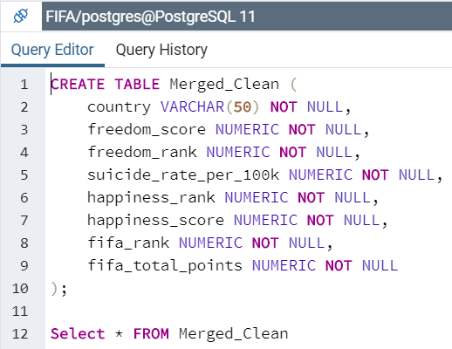

CREATE TABLE Merged_Clean (

country VARCHAR(50) NOT NULL,

freedom_score NUMERIC NOT NULL,

freedom_rank NUMERIC NOT NULL,

suicide_rate_per_100k NUMERIC NOT NULL,

happiness_rank NUMERIC NOT NULL,

happiness_score NUMERIC NOT NULL,

fifa_rank NUMERIC NOT NULL,

fifa_total_points NUMERIC NOT NULL

);

Select * FROM Merged_Clean